**AIR QUALITY INDEX ANALYSIS**

**What is Air Quality Index?**

The AQI or the Air Quality Index is like a score that government groups use to tell people how clean or polluted the air is. It helps everyone understand how the air quality might affect their health. The higher the AQI number is, the more likely it is that many people could face health issues. To find and calculate the AQI, we have special devices to measure how much pollution is in the air over a certain time. The results are sorted into different levels, each with a description, colour code, and advice about how it might affect public health. So, if the AQI goes up, it is a sign that the air might not be healthy for everyone.

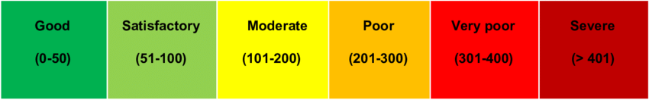

**How is it measured?**

The Air Quality Index (AQI) is a measure of how clean or polluted the air is, and it is calculated separately for different pollutants like particulate matter or ozone. The formula involves looking at the concentration of each pollutant, comparing it to specific thresholds or breakpoints, and assigning an AQI value based on the level of pollution. The final AQI is determined by the worst result from these individual calculations, reflecting the overall air quality. It is like a simplified report card that condenses information about various pollutants into a single number, making it easier for people to understand and respond to potential health risks associated with different air quality levels.

**The formula to calculate AQI is**

**Ip = [IHi – ILo / BPHi – BPLo] (Cp – BPLo) + ILo**

Where,

**Ip** = index of pollutant p  
**Cp** = truncated concentration of pollutant p  
**BPHi** = concentration breakpoint i.e. greater than or equal to Cp  
**BPLo**= concentration breakpoint i.e. less than or equal to Cp  
**IHi** = AQI value corresponding to BPHi  
**ILo**= AQI value corresponding to BPLo

The Indian AQI range is different from that of the US-EPA.

To calculate the AQI, a minimum of three parameters should be taken out of which one must be either PM10 or PM2.5.

To showcase AQI factors and their affecting rate I have created a user-friendly interface that consolidates data from various environmental factors, providing a visual representation of air quality.

The data was collected from an Air Quality Station for Gujarat location. We have AQI of 8 cities of Gujarat.

Look at the Power BI dashboard I have created to monitor the Air Quality Index (AQI). The interactive charts and graphs simplify the interpretation of pollutant levels, offering a comprehensive snapshot of the air quality conditions for informed decision-making and public awareness.

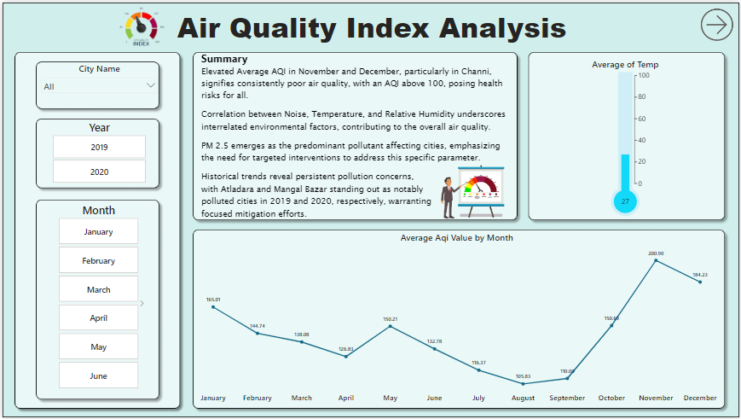**Dashboards:**

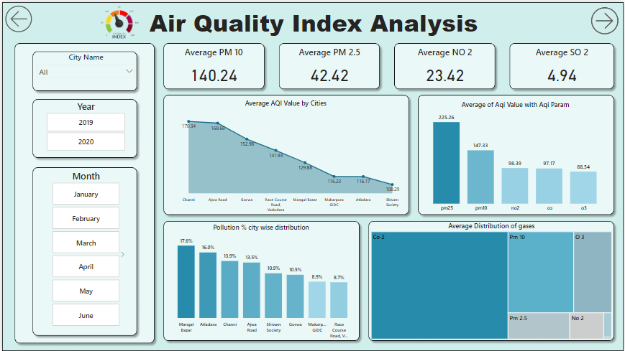

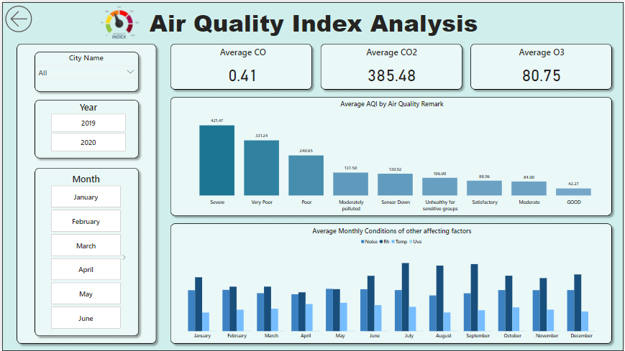

These are our Dashboards (Db_1, Db_2, Db_3), these dashboards are interactive dashboards which means that it allows users to explore data in a more engaging and dynamic way where the users can interact with the data by drilling down it into specific visualizations, filtering data, or changing the view of the data according to the visualization.

Let us check the charts and other tools in our dashboards which gives us insights and tells us the story of the data as the visualization should tell us the story of the data as that is our main goal.

**Slicer:**

A slicer in Power BI is like a filter tool that lets you easily focus on specific data in your reports or dashboards.

It helps you interactively analyse and view aspects of your information by selecting values such as categories or time periods.

In our Dashboard we have used slicer for Date Hierarchy (Month, Year) and for City names.

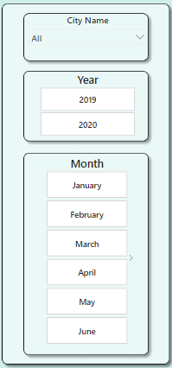

**KPI (Key Performance Indicator):**

It is a measure used to evaluate the performance of an organization or a specific aspect of a business. KPIs help track progress towards goals and provide valuable insights for decision-making.

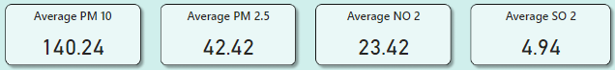In Power BI, KPIs are visualized using indicators such as icons, gauges, or data bars to display performance status briefly.

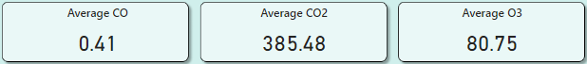

In our Dashboard we have used the major Air Quality affecting factors as KPI’s.

We have used average of PM 10, PM 2.5, NO 2, SO 2, CO, CO 2, O3 as KPI’s in our dashboard.

* **Average PM 10:** This KPI is one of the two major affecting factors for quality of air and we have averaged it.
* **Average PM 2.5:** This KPI represents the average count of PM 2.5 available in air.
* **Average NO 2:** It indicates the average number of nitrogen dioxide (NO2) level in air.
* **Average SO 2:** It represents the average of sulfur dioxide (SO2) in air.
* **Average CO:** In this KPI, it tells us the average amount of carbon monoxide (CO) present in air.
* **Average CO 2:** This KPI shows us the average count of Carbon dioxide (CO2) in air.
* **Average O3:** This KPI gives us the average of Ground-level ozone (O3).

**DAX (Data Analysis Expressions):**

It is a formula language used in Power BI and other Microsoft products like Excel and SQL Server Analysis Services (SSAS).

DAX allows users to create custom calculations and expressions to manipulate data, perform calculations, and create complex measures and calculated columns.

We have used DAX to create KPIs, measures, and columns, enabling us to gain deeper insights and make data-driven decisions with ease.

**Chart 1 – Average AQI value by Month:**

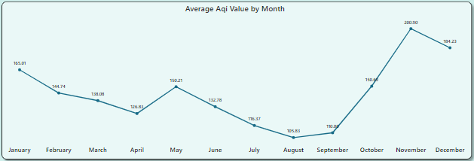

* We used a line chart to visualize the trend of AQI value by months.
* The X-axis represents the date table with months from January to December.
* The Y-axis shows the average AQI value.
* This allows the user to drill up and down to explore average AQI trends at different time granularities.

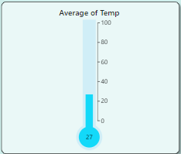**Chart 2 – Average Temperature gauge chart:**

* To check average temperature, we used thermometer gauge chart.
* With the use of DAX measures, we calculated the average of Temperature.
* It tells us the average temperature at different cities yearly and monthly wise.

**Chart 3 – Average AQI value by cities:**

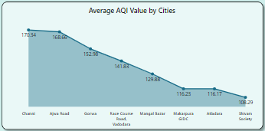

* We used stacked area chart to show average AQI values by Cities.
* A stacked Area chart is used to show how numerical values change based on a second variable, usually a time period.
* A stacked Area chart is used when we want to visualize how a measure, observed through multiple category values, changes over time.
* We used DAX to calculate Average of AQI values.



**Chart 4 – Average AQI value with AQI parameters:**

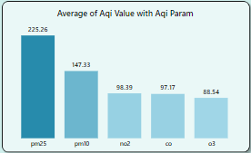

* We used stacked column chart to show average AQI values with AQI parameters.
* A stacked column chart is used to show data changes over a period of time or for illustrating comparisons among items
* A stacked Area chart is used when we want to compare total values across categories.
* We used DAX to calculate Average of AQI values.

**Chart 5 – Average AQI value with AQI parameters:**

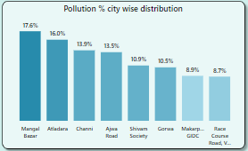

* We used stacked column chart to show percent of Grand total for the sum of total pollution city wise.
* we used pastel shades colouring to show the transparency of pollution from low to high.
* We calculated total pollution using DAX by adding all the affecting factors.

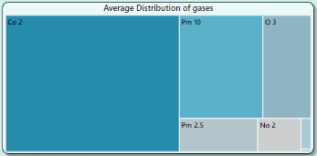**Chart 6 – Average AQI value with AQI parameters:**

* TreeMap in Power BI is the hierarchical chart, which is used to show the parent and child data distribution.
* TreeMap is shown by a group of rectangles, these rectangles are segregated based on the category.
* Here we see TreeMap containing the parameters and their spread.

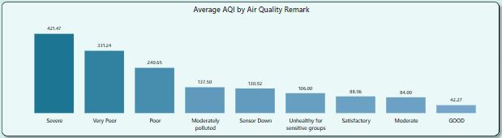**Chart 7 – Average AQI value with Air Quality Remark:**

* We used stacked column chart to show the average of AQI and in which category does it fall.
* we used pastel shades colouring to show the transparency for remarks from good to Severe.

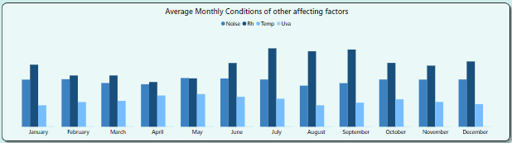**Chart 8 – Average monthly conditions of other affecting factors:**

* We used clustered column chart to show the distribution of other factors affecting air (Noise, Rh, Temp, Uva) month wise.
* we used pastel shades colouring to show the different bars of different factors.
* We calculated average for the factors and then used them for our need.

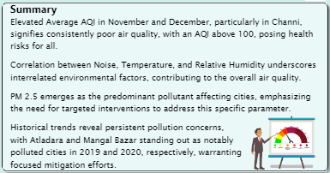**Chart 9 – Summary:**

* Using a text box, we created a summary box.
* In this summary box we have noted down the observations that we gathered from our visualization.
* This summary box lets us know the observations of our visualizations.